### A PROJECT REPORT

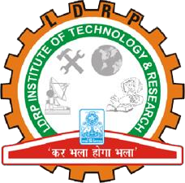

***Submitted by***

**PATEL RUDRA**

**CHAUDHARY TUSHYAM**

**AGRAWAL PRATHAM**

**ACHARYA YAGNANG**

***In fulfillment for the award of the degree of***

**BACHELOR OF ENGINEERING**

***in***

Computer Engineering

**LDRP Institute of Technology and Research, Gandhinagar**

**Kadi Sarva Vishwavidyalaya**

**ANONYMOUS FEEDBACK**

### July -2024

**LDRP INSTITUTE OF TECHNOLOGY AND RESEARCH GANDHINAGAR**

#### CE-IT Department

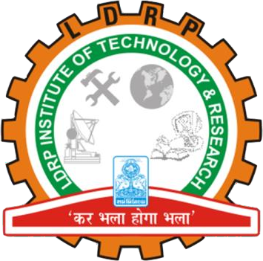

CERTIFICATE

This is to certify that the Project Work entitled **“Anonymous Feedback System”** has been carried out by **PATEL RUDRA (21BECE30229)** under my guidance in fulfilment of the degree of Bachelor of Engineering in Computer Engineering Semester-7 of Kadi Sarva Vishwavidyalaya University during the academic year July-2024.

Prof. NIMESH PATEL Dr. Sandip Modha

#### Internal Guide Head of the Department

**LDRP ITR LDRP ITR**

**LDRP INSTITUTE OF TECHNOLOGY AND RESEARCH GANDHINAGAR**

#### CE-IT Department



CERTIFICATE

This is to certify that the Project Work entitled **“Anonymous Feedback System”** has been carried out by **CHAUDHARY TUSHYAM (21BECE30030)** under my guidance in fulfilment of the degree of Bachelor of Engineering in Computer Engineering Semester-7 of Kadi Sarva Vishwavidyalaya University during the academic year July-2024.

Prof. NIMESH PATEL Dr. Sandip Modha

#### Internal Guide Head of the Department

**LDRP ITR LDRP ITR**

**LDRP INSTITUTE OF TECHNOLOGY AND RESEARCH GANDHINAGAR**

#### CE-IT Department



CERTIFICATE

This is to certify that the Project Work entitled **“Anonymous Feedback System”** has been carried out by **AGRAWAL PRATHAM (21BECE30005)** under my guidance in fulfilment of the degree of Bachelor of Engineering in Computer Engineering Semester-7 of Kadi Sarva Vishwavidyalaya University during the academic year July-2024.

Prof. NIMESH PATEL Dr. Sandip Modha

#### Internal Guide Head of the Department

**LDRP ITR LDRP ITR**

**LDRP INSTITUTE OF TECHNOLOGY AND RESEARCH GANDHINAGAR**

#### CE-IT Department



CERTIFICATE

This is to certify that the Project Work entitled **“Anonymous Feedback System”** has been carried out by **ACHARYA YAGNANG (21BECE30003)** under my guidance in fulfilment of the degree of Bachelor of Engineering in Computer Engineering Semester-7 of Kadi Sarva Vishwavidyalaya University during the academic year July-2024.

Prof. NIMESH PATEL Dr. Sandip Modha

#### Internal Guide Head of the Department

**LDRP ITR LDRP ITR**

**Presentation- l for Project- ll**

|  |  |
| --- | --- |
| **1. Name & Signature of Internal Guide** |  |
| **2. Comments from Panel Members** |  |
| **3. Name & Signature of Panel Members** |  |

**Presentation- ll for Project- ll**

|  |  |
| --- | --- |
| **1. Name & Signature of Internal Guide** |  |
| **2. Comments from Panel Members** |  |
| **3. Name & Signature of Panel Members** |  |